Software Requirement Specifications
IoT-Based Bluetooth Controlled Smart Car


Submitted by
Muhammad Farhan (F22BINFT1E02106)
Muhammad Junaid (F22BINFT1E02132)
Submitted to
Dr. Musarat Karim

Department of Information Technology
Faculty of Computing
The Islamia University of Bahawalpur

Summary
This Software Requirements Specification (SRS) defines the full requirements of the IoT-Based Bluetooth Controlled Smart Car. It outlines system objectives, features, functional and non-functional requirements, use cases, technology stack, and system flow. The smart car uses Arduino, HC-05 Bluetooth, L298N motor driver, and a mobile app to allow wireless movement control.
Table of Contents
1. Introduction 1
1.1. Purpose 1
1.2. Scope 1
1.3. Product Perspective 1
1.4. User Characteristics 1
1.5. Similar apps and systems/Literature Review 1
1.6. Proposed Technologies 2
2. Requirements 2
2.1. Function Requirements 2
2.2. Non-Functional Requirements 3
3. Use Cases and Flow of Processes 4
3.1. Use Case 1 4
4. References 5

Introduction
This project aims to design and develop an IoT-Based Bluetooth Controlled Smart Car using Arduino UNO, Bluetooth Module HC-05, L298N Motor Driver, and DC motors. The system enables users to wirelessly control movement (forward, backward, left, right, stop) through a mobile application. This system demonstrates embedded systems, IoT basics, motor control, and wireless communication.
  - Purpose
The main purpose of this project is to develop a low-cost, wireless control system for a robotic vehicle, demonstrating the seamless integration of hardware and software using Arduino and Bluetooth technology. It aims to provide hands-on experience in wireless data transmission, motor control, and microcontroller programming, while serving as a practical showcase of these concepts. Additionally, this project establishes a foundational model that can be further expanded into advanced IoT or AI-based robotic systems, such as fire-detection robots or obstacle-avoiding vehicles.
1.2 Scope
The scope includes implementing directional control, Bluetooth communication, LED indication, and mobile app operation. The system does NOT include IoT cloud control, cameras, GPS, obstacle detection, or autonomous navigation in this version
1.3 Product Perspective
The Smart Car acts as a standalone embedded system. Bluetooth signals from a mobile phone are received by HC-05 and processed by Arduino UNO to control motor driver operations.
1.4 User Characteristics
The user only needs basic smartphone knowledge. Developers require basic electronics and Arduino coding knowledge.
1.5 Similar Apps and Systems / Literature Review
Similar Bluetooth robotic cars exist but lack professional documentation, expandability, and IoT integration. This project is designed with modularity and extendability in mind.

1.6 Proposed Technologies
Arduino UNO, HC-05 Bluetooth Module, L298N Motor Driver, DC Motors, Arduino IDE, Mobile Bluetooth App, Rechargeable Battery Pack.
2. Requirements
The Smart Car receives Bluetooth commands and moves accordingly. Commands include: Forward, Backward, Left, Right, Stop. Arduino processes the input and controls the motors via L298N motor driver.
2.1 Functional Requirements

Bluetooth Connection
Name: FR001
Purpose: Allows user to pair mobile with HC-05.
User(s): User
Input: Pairing code 1234/0000
Output: Bluetooth connected

Move Forward
Name: FR002
Purpose: Moves the car forward.
User(s): User
Input: Command: F
Output: Car moves forward

Move Backward
Name: FR003
Purpose: Moves the car backward.
User(s): User
Input: Command: B
Output: Car moves backward

Turn Left
Name: FR004
Purpose: Turns the car left.
User(s): User
Input: Command: L
Output: Car turns left

Turn Right
Name: FR005
Purpose: Turns the car right.
User(s): User
Input: Command: R
Output: Car turns right

Stop Car
Name: FR006
Purpose: Stops all motor movement.
User(s): User
Input: Command: S
Output: Car stops
2.2 Non-Functional Requirements
• Performance: Response time < 0.5 seconds.
• Reliability: Stable connection up to 10 meters.
• Usability: Easy-to-use interface.
• Safety: Should stop motors if Bluetooth disconnects.
• Maintainability: Code should be modular for future IoT upgrade.

3. Use Cases and Flow of Processes
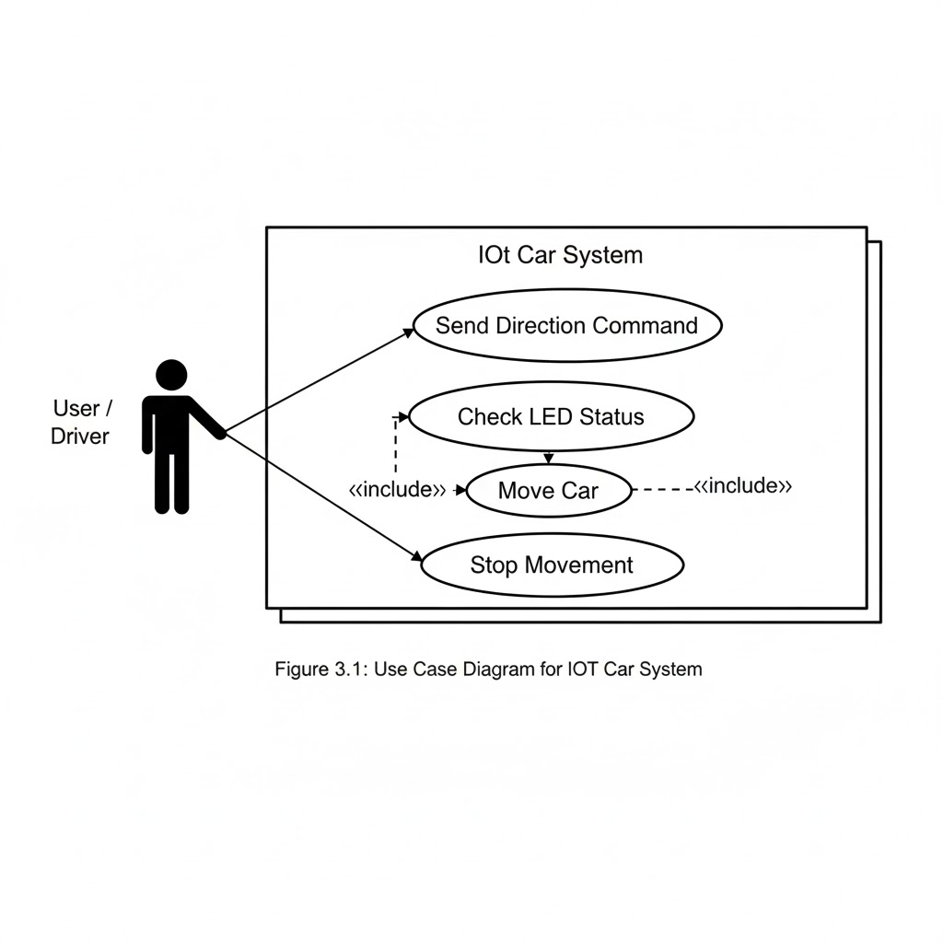Figure 3.1 shows the high-level interaction between the user and the IoT Car System.
The user sends direction commands (forward, backward, left, right) through the mobile Bluetooth app. The system then performs internal actions such as checking LED status and activating the motor to move the car. The stop command allows the user to immediately halt movement at any time. The <<include>> relationships in the diagram show that internal system processes must run whenever a command is executed.
3.1 Use Case 1 – Control Car Movement
ID | UC001
Name | Control Car Movement
Description | This use case describes how the user controls the car’s movement through Bluetooth commands.
Actor(s) | User / Driver
Precondition | Mobile phone must be paired with HC-05 Bluetooth module.
Postcondition | Car responds and completes the requested movement.
Basic Flow
- User opens the Bluetooth controller app on the smartphone.
- User pairs the phone with the HC-05 Bluetooth module.
- User selects a directional command (Forward / Backward / Left / Right / Stop).
- System receives the command.
- Motor driver activates motors and moves the car.
Alternative Flow
- If the connection drops, the system immediately stops the car for safety.
Exceptions
- Command not received
- Invalid command sent
- Bluetooth pairing failed
- Hardware malfunction (e.g., motor driver problem)
4. References
[1] Arduino, “Arduino UNO Documentation.” Available: https://www.arduino.cc
[2] YouTube, “Bluetooth Controlled Car Using Arduino,” YouTube video, 2024.
[3] HC-05 Bluetooth Module, “Technical Datasheet,” JNHuaMao Technology.

